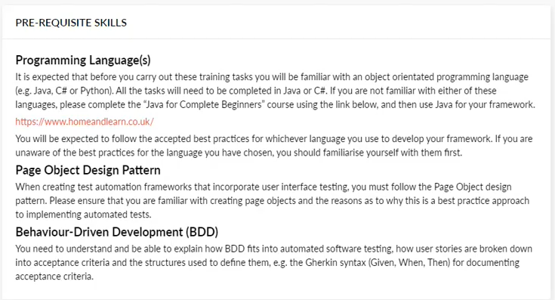
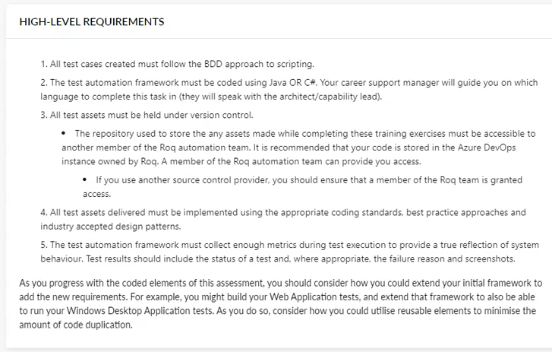
BDD style framework – Kittens. Follow same Page object model.
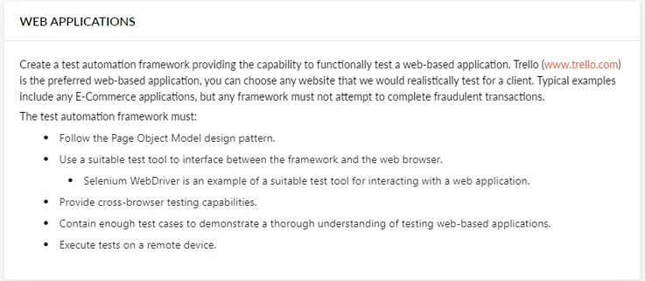
Follow the units. Best practice. Requires reporting and multi browser testing. Can have separate projects for each section. Can use any web app you want.
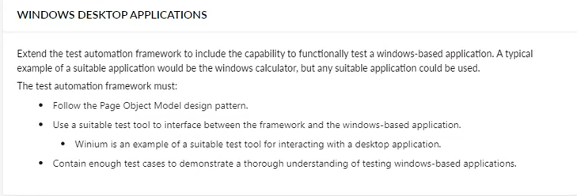
Similarities to web application steps. Can use - Winium, Apium, winappdriver (use this one?).
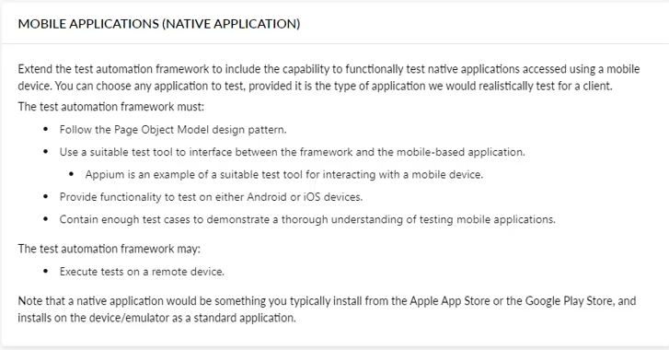
Must test both web app and native app (downloaded from app store, reddit? Can be any). For the web app either chrome or safari if testing an iPhone. Can do android or iOS device. Appium is an example of a tool, but you can use any that you find.
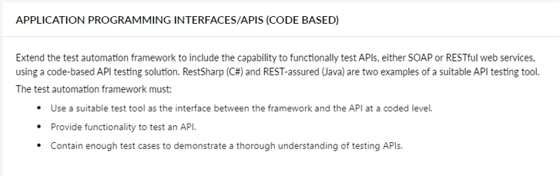
Need to have it in code as well as a tool. Postman – can get tests up and running with that first. Then go over to the code.
APPLICATION PROGRAMMIG INTERFACE/APIS (Tool Based)
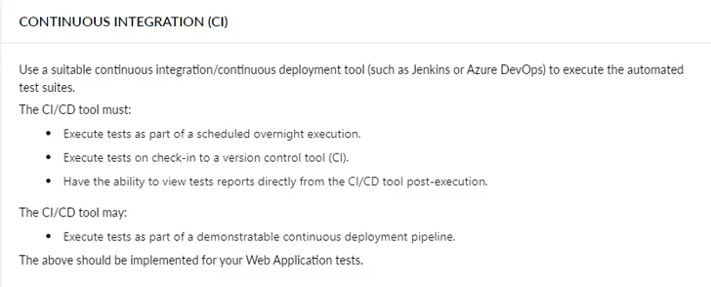
Best left to the end. Need to schedule an overnight execution – tools such as DevOps or Jenkins.
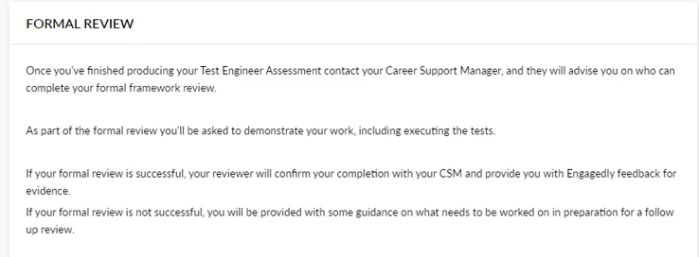
Formal sign off at the very end.

https://testifyqa.com/

'I' started off with maybe trying to write a gherkin format steps for the scenarios we were given in the task section - emphasis on the 'I'

[3:16 PM] James Croxford
Docker & Docker Desktop
Hi everyone. As part of building my own automated test framework I’ve had to learn more about Docker, and how it can be used to simulate functional UI tests on a remote browser.

Given there’s a lot of apprentices & academy consultants looking to do the same, I thought I’d link to this video guide which I found really helpful for an overview of the Docker platform:
https://www.youtube.com/watch?v=pg19Z8LL06w

In short, Docker allows you to distribute and access applications which are containerised. Software is packaged into standardised units which run in their own walled-off environment, and come pre-packaged with all software dependencies and configuration settings included. This removes many of the headaches that can come with installation and setup issues.

The guide is an hour long, but has timestamps so you can just watch the parts relevant to you. It provides context as to what Docker is, how and why it has become so popular for developing & distributing applications, what it does differently to other virtualisation tools such as virtual machines, and some basics on Docker Commands.

Below I've included some of the notes I made based on the video tutorial:
Two key bits of terminology to grasp are Docker Images and Docker Containers:

Docker Images
- An executable application artifact
- Can be obtained through Docker image repos such as ‘Docker Hub’
- Unlike traditional artifacts (just app source code) a Docker Image also includes a complete environment configuration:
  - Source Code (e.g. a JavaScript app)
  - Any services needed (e.g. node, npm)
  - OS layer
  - Any environment variables needed- e.g. directories, files, etc.

Docker Containers
- Actually starts the application
- When we download an image down to the local computer/server we want to run that image
- When an image is run on an OS, and the app starts in the pre-configured environment, that gives us a Docker Container
- A Container is a running instance of an image
- From one Docker Image, you can run multiplate Containers (e.g. needing to run multiple instances of the same application)

Accessing Docker Desktop
On your ROQ laptops you can download Docker Desktop via Microsoft Intune, although you may also need to request access to the ‘Docker-users’ group via Seriun to use it. Docker Desktop will provide you with a nice visual GUI component, but also a command line interface which can be accessed via CMD.

Core Docker Commands
These are the core commands shown in the linked video (once Docker Desktop is installed these can be used in CMD/terminal):
- ‘docker images’- shows all images stored locally
- ‘docker ps’ see all containers in running container list
- ‘docker run {image_name}:{tag}’ - starts docker container using the specified image name and tag (tag being a version number of the image, e.g. Firefox version 118, 110, etc). If the specified image is not available on the local machine, then it will be pulled down from the default Docker Image Registry (usually Docker Hub)
- ‘docker run -d {image_name}:{tag}’ - ‘docker -d’ or ‘docker —detach’ runs the container in the background and prints the container ID. By running in detached mode the terminal is not blocked from use whilst the container is active).
- ‘docker run {image_name}:{tag} locally’ - This command will try to locate the specified image locally, and if not pull from Docker Hub. It will then run the image and start the container
- ‘docker stop {container_ID}’- stops the specific running container
- ‘docker run -d -p {HOST_PORT}:{CONTAINER_PORT} {image_name}:{tag}’ - start a container based on the specified image name and tag, binding the specified host port to the container port. The binding process will allow access to the containerised application from your local computer
- ‘-p {HOST_PORT}:{CONTAINER_PORT}’ or ‘—publish {HOST_PORT}:{CONTAINER_PORT}’ - ****This tells docker to bind the container port to a specified local port
- ‘docker ps -a’ this command will give a list of all containers, whether they are started or stopped
- ‘docker start {container_ID}’ - start one or more stopped containers
- ‘docker run —name {ASSIGNED_ NAME} -d -p {HOST_PORT}:{CONTAINER_PORT} {image_name}:{tag}’ - start a detached container based on the specified image name and tag, binding the specified host port to the container port, and providing the container an assigned name using the ‘—name’ operator
- ‘docker logs {ASSIGNED_NAME}’ - check the logs of the specified container. With an assigned name it is possible to see logs of a container more easily compared to relying on container IDs

Example Docker CLI input:
docker run --name selenium_chrome_120 -d -p 4444:4444 -p 7900:7900 --shm-size="2g" selenium/standalone-chrome:120.0
Entering this into the CLI would create a Docker container. To break this down:
- ‘docker run’: creates and starts the container
- ‘—name selenium_chrome_120’: the container has been assigned a name of ‘selenium_chrome_120’
- ‘-d’ it will run in a detached mode (i.e. not blocking the terminal from use whilst the container is running)
- ‘-p 4444:4444’ binds the host port of ‘4444’ to the container port of ‘4444’. Any selenium tests would pointed to run against this host port from within a Selenium Web Driver class file. Best practice is to set the host port to the same as the specified container port.
- ‘-p 7900:7900’: this binds another host port to a different container port. In this case, this port number binding will allow you to watch selenium tests execute on the host device via the host port number using the following link: http://localhost:7900/?autoconnect=1&resize=scale&password=secret
- ‘—shm-size=”2g”’ : sets the shared memory size as part of resource management
- ‘selenium/standalone-chrome:120.0’: the created container will be based on an image of ‘selenium/standalone-chrome’, tag/version/release number being ‘120.0’
Once this Docker command is run the created container can seen via CMD and also in the Docker GUI:
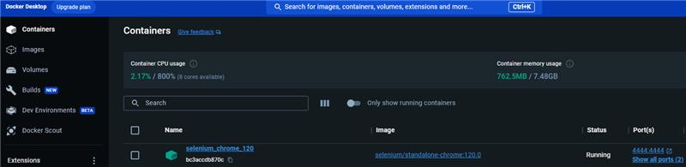

Hope you find this helpful!
heart 2
Docker Crash Course for Absol…
1.1M views · 11 months ago

